**JCB Safety Shoes**

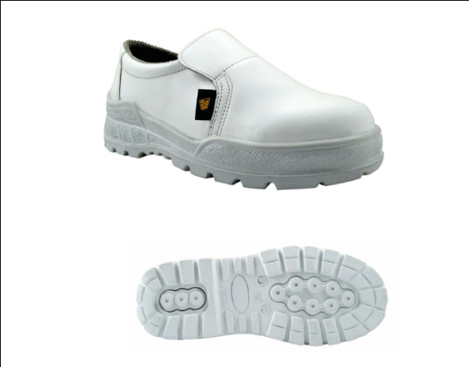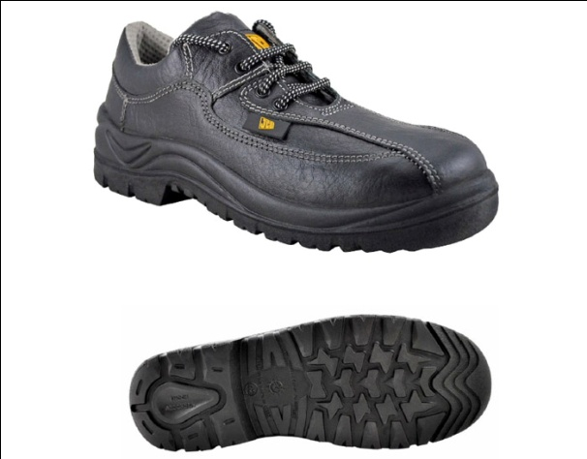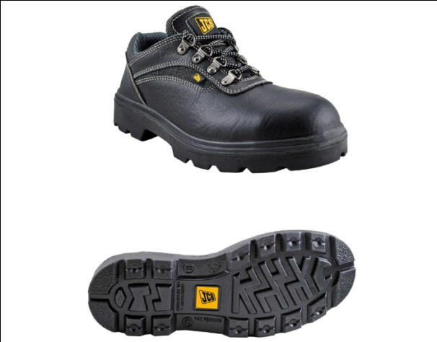

### JCB CLEAN PRO JCB DUCHESS JCB EARTCMOVERS

### http://capricornsafety.co.in/images/safety-shoes/4.jpghttp://capricornsafety.co.in/images/safety-shoes/5.jpghttp://capricornsafety.co.in/images/safety-shoes/6.jpg

### JCB EXCAVATOR JCB EXEC SHOE JCB HEATMAX

### http://capricornsafety.co.in/images/safety-shoes/7.jpghttp://capricornsafety.co.in/images/safety-shoes/8.jpghttp://capricornsafety.co.in/images/safety-shoes/9.jpg

### JCB PICKER JCB POWER JCB TREKKER